Tameka Fryer Brown
Children’s Book Author

MY COLD PLUM LEMON PIE BLUESY MOOD
Illustrated by Shane W. Evans
Viking Children’s/Penguin Random House, 2013
ISBN-10: 0670012858 / ISBN-13: 978-0670012855

AROUND OUR WAY ON NEIGHBORS’ DAY
Illustrated by Charlotte Riley-Webb
Abrams Books for Young Readers, 2010
ISBN-13: 978-0-8109-8971-9

BROWN BABY LULLABY
Illustrated by AG Ford
FSG/Macmillan, coming January 2020
ISBN-10: 0374307520 / ISBN-13: 978-0374307523

Tameka Fryer Brown (a native of Miami, Florida) has called Charlotte, North Carolina home for over 20 years. Brown’s first literary accomplishment as a children’s book writer came when she was awarded one of two First Prizes in the 2008 Cheerios® Spoonfuls of Stories® New Author Contest. Her debut picture book, Around Our Way on Neighbors’ Day, was published by Abrams Books for Young Readers and illustrated by Charlotte Riley-Webb. To date, it has sold over 100,000 copies, a great number having been purchased by New York’s Board of Education.
My Cold Plum Lemon Pie Bluesy Mood is Brown’s second picture book. It is published by Viking Children’s/Penguin Random House and illustrated by the award-winning Shane W. Evans. Its awards and accolades include a Charlotte Zolotow Honor Award for excellence in picture book text, and designations as a Bank Street College Best Book, a CCBC Choices Best Book, and one of NYPL’s 100 Titles for Reading and Sharing. Her work is also featured in the much heralded We Rise, We Resist, We Raise Our Voices, published by Crown Books for Young Readers in partnership with Just Us Books.
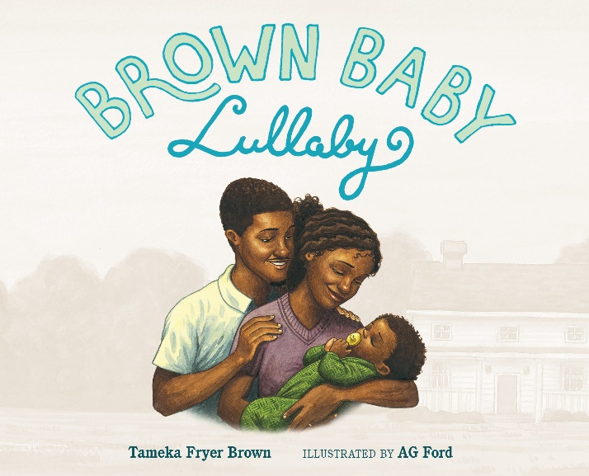
In January of 2020, Brown’s third book, Brown Baby Lullaby will be published by Farrar, Straus & Giroux/Macmillan. In the story, Momma and Papi struggle to get through the evening's routine with their high-energy toddler—but they wouldn’t have their sweet, brown baby any other way. Twelve Dinging Doorbells, Brown’s fourth book and a celebration of Black family gatherings, will be published by Kokila/PRH in 2022. For more information, visit tamekafryerbrown.com .

