TAMEKA FRYER BROWN
SHORT BIO TEXT

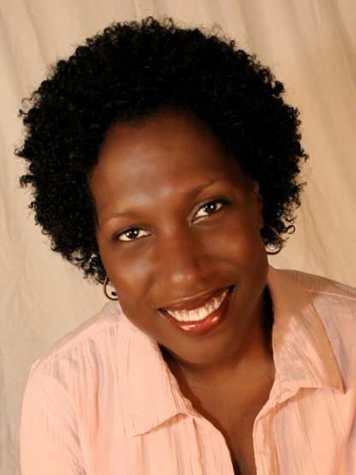

TAMEKA FRYER BROWN is an award-winning picture book author. Her titles include AROUND OUR WAY ON NEIGHBORS’ DAY (Abrams BFYR) and MY COLD PLUM LEMON PIE BLUESY MOOD (Viking Children’s/PRH), which was lauded as a Charlotte Zolotow Honor Book, a Bank Street College Best Book, a CCBC Choices Best Book, an Abilene ISD Mockingbird Award nominee, a SIBA Book Award nominee, a Star of the North Picture Book Award nominee, and one of NYPL’s 100 Titles for Reading and Sharing. Her work is also featured in the much-heralded anthology, WE RISE, WE RESIST, WE RAISE OUR VOICES (Crown BFYR/Just Us Books). Brown’s forthcoming picture books, BROWN BABY LULLABY (FSG//Macmillan) and TWELVE DINGING DOORBELLS (Kokila/PRH) are scheduled for release in 2020 and 2022 respectively. To learn more about Tameka Fryer Brown, visit tamekafryerbrown.com.

