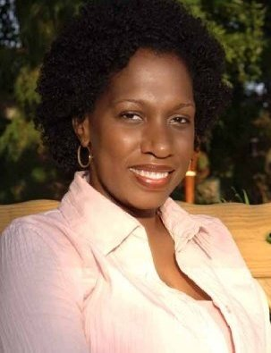
Tameka Fryer Brown
Children’s Book Author

BROWN BABY LULLABY
Illustrated by AG Ford
FSG/Macmillan
ISBN-10: 0374307520 / ISBN-13: 978-0374307523

MY COLD PLUM LEMON PIE BLUESY MOOD
Illustrated by Shane W. Evans
Viking Children’s/Penguin Random House
ISBN-10: 0670012858 / ISBN-13: 978-0670012855

AROUND OUR WAY ON NEIGHBORS’ DAY
Illustrated by Charlotte Riley-Webb
Abrams Books for Young Readers
ISBN-13: 978-0-8109-8971-9

Tameka Fryer Brown (a native of Miami, Florida) has called Charlotte, North Carolina home for over 20 years. Brown’s first literary accomplishment as a children’s book writer came when she was awarded one of two First Prizes in the 2008 Cheerios® Spoonfuls of Stories® New Author Contest. Her debut picture book, Around Our Way on Neighbors’ Day, was published by Abrams Books for Young Readers and illustrated by Charlotte Riley-Webb. To date, it has sold over 100,000 copies, a great number having been purchased by New York’s Board of Education.
My Cold Plum Lemon Pie Bluesy Mood is Brown’s second picture book. It is published by Viking Children’s/Penguin Random House and illustrated by the award-winning Shane W. Evans. Its awards and accolades include a Charlotte Zolotow Honor Award for excellence in picture book text, and designations as a Bank Street College Best Book, a CCBC Choices Best Book, and one of NYPL’s 100 Titles for Reading and Sharing. Her work is also featured in the much heralded We Rise, We Resist, We Raise Our Voices, published by Crown Books for Young Readers in partnership with Just Us Books.
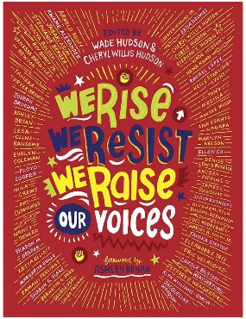
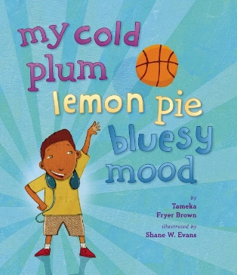
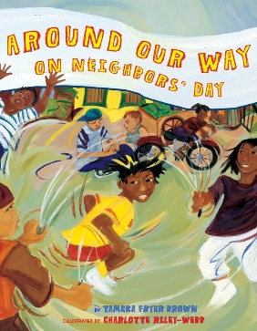
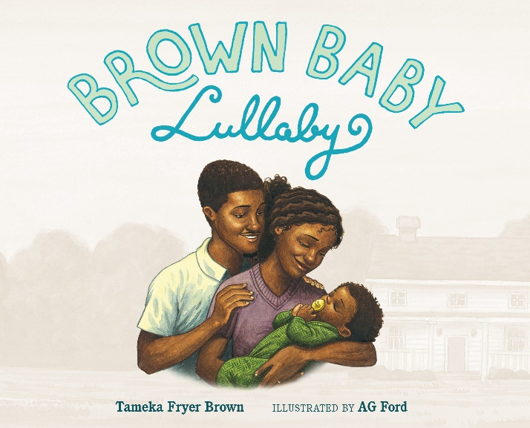
In January of 2020, Brown’s third book, Brown Baby Lullaby was published by Farrar, Straus & Giroux/Macmillan. In a starred review, Kirkus describes it as a “perfect read-aloud for bedtime”. It is a Parents Latina Magazine's Best Latino Children's Book of 2020, and one of NPR's 100 Favorite Books for Young Readers. Forthcoming titles from Brown include Twelve Dinging Doorbells (Kokila/PRH, 2022), Shirley Chisholm: Not Done Yet (Millbrook Press/Lerner, 2022), and That Flag (HarperCollins, 2023). For more information, visit tamekafryerbrown.com .

