TAMEKA FRYER BROWN
SHORT BIO TEXT

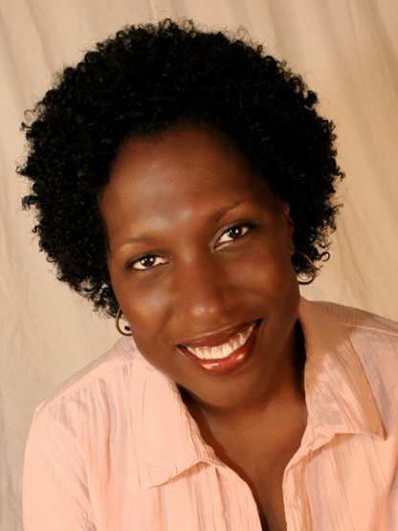

Tameka Fryer Brown is an award-winning picture book author. Her titles include AROUND OUR WAY ON NEIGHBORS’ DAY (Abrams), MY COLD PLUM LEMON PIE BLUESY MOOD (Viking/PRH), and BROWN BABY LULLABY (FSG/Macmillan). Her work is also featured in the much-heralded anthology, WE RISE, WE RESIST, WE RAISE OUR VOICES (Crown/PRH & Just Us Books).
Brown’s forthcoming picture books are TWELVE DINGING DOORBELLS (Kokila/PRH, 2022), SHIRLEY CHISHOLM: NOT DONE YET (Millbrook Press/Lerner, 2022), and THAT FLAG (HarperCollins, 2023). To learn more about Tameka Fryer Brown, visit tamekafryerbrown.com.

