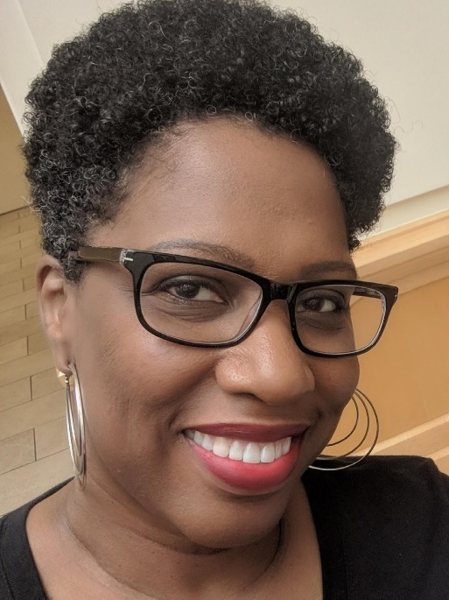**Tameka Fryer Brown**

*Children’s Book Author*

**Tameka Fryer Brown**, a native of Miami, Florida, has called Charlotte, North Carolina home for over 25 years. She is a picture book author who writes to sow seeds of self-love, pride, connectivity, and inclusion in the hearts of children. Her first literary accomplishment as a children’s book writer came when she was awarded one of two First Prizes in the 2008 Cheerios® Spoonfuls of Stories® New Author Contest. Her books have won awards like the Charlotte Huck Honor Award, the Charlotte Zolotow Honor Award, and the Jane Addams Children’s Book Honor Award. They have also been featured on best book lists by the Cooperative Children’s Book Center, New York Public Library, Kirkus, Bank Street College, NPR, Parents Latina Magazine, Little Free Library, and more.

Tameka’s recent titles include *Twelve* *Dinging Doorbells*, *That Flag*, and *All the Greatness in You*. Her next book, *Prayer Is*, will be published in 2026. In her spare time, Tameka enjoys the homebody life, which includes hanging out with loved ones, playing games, Netflix binging, and debating pretty much everything.

A proud member of [The Brown Bookshelf](http://thebrownbookshelf.com/), [Writers & Illustrators of North Carolina](http://www.wincbooks.com/), and [Alpha Kappa Alpha Sorority, Incorporated](https://aka1908.com/), Tameka is represented by Marietta B. Zacker of [Gallt & Zacker Literary Agency](https://www.galltzacker.com/gzla-team.html). Learn more about Tameka and her work at [tamekafryerbrown.com](http://tamekafryerbrown.com/).

[**ALL THE GREATNESS IN YOU**](https://us.macmillan.com/books/9780374391010/allthegreatnessinyou/)

*Illustrated by Alleanna Harris*

*FSG/Macmillan*

*ISBN: 9780374391010*

*Publication Date: November 5, 2024*

[**NOT DONE YET: SHIRLEY CHISHOLM’S FIGHT FOR CHANGE**](https://lernerbooks.com/shop/show/21881)

*Illustrated by Nina Crews*

*Millbrook Press/Lerner Publishing*

*ISBN: 9781728420080*

*Publication Date: November 1, 2022*

[**BROWN BABY LULLABY**](https://us.macmillan.com/books/9780374389819/brownbabylullaby)

*Illustrated by AG Ford*

*FSG/Macmillan*

*ISBN: 9780374307523*

*Publication Date: January 14, 2020*

[**THAT FLAG**](https://www.harpercollins.com/products/that-flag-tameka-fryer-brown?variant=40397726449698)

*Illustrated by Nikkolas Smith*

*HarperCollins*

*ISBN: 9780063093447*

*Publication Date: January 31, 2023*

[**TWELVE DINGING DOORBELLS**](https://www.penguinrandomhouse.com/books/609778/twelve-dinging-doorbells-by-tameka-fryer-brown-illustrated-by-ebony-glenn/)

*Illustrated by Ebony Glenn*

*Kokila/Penguin Young Readers*

*ISBN: 9781984815170*

*Publication Date: October 18, 2022*

[**MY COLD PLUM LEMON PIE BLUESY MOOD**](https://www.penguinrandomhouse.com/books/308091/my-cold-plum-lemon-pie-bluesy-mood-by-tameka-fryer-brown-illustrated-by-shane-evans/)

*Illustrated by Shane W. Evans*

*Viking Children’s/Penguin Random House*

*ISBN: 9780670012855*

*Publication Date: March 7, 2013*

**[AROUND OUR WAY ON NEIGHBORS’ DAY](https://tamekafryerbrown.com/books/aroundourway/)**

*Illustrated by Charlotte Riley-Webb*

*Abrams Books for Young Readers  
ISBN: 9780810989719*

*Publication Date: August 1, 2010*